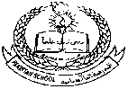 **Pakistan School, Kingdom of Bahrain**

**E- Support and Learning Material / Session 2020-2021**

**Subject: Islamiat: Grade: 1**

**Topic: ISLAMIC MANNERS - SNEEZING**

**Name: ___________________________________________**

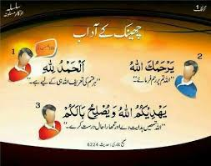

**1. Cover your nose while sneezing.**

**2. After sneezing say ALHAMDOLILLAH.**

**3. On hearing ALHAMDOLILLAH , the hearer must say YAR HA MU KALLAH.**

**4. The Sneezer must then reply as**

**YAH DEE KU MULLAH WA YUS LI HU BALA KUM**

**OR can say YAH DEE KU MULLAH.**

* **LOOK , THINK AND CIRCLE THE RIGHT ACTION:**

** **

**MATCH THE FOLLOWING:**

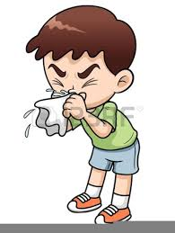

**يَهدِيكُمُ اللهُ**

**يَهدِيكُمُ اللهُ وَ يُصلِحُ بَالَكُم**

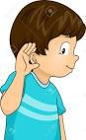

**اَلحَمدُ ِلله**

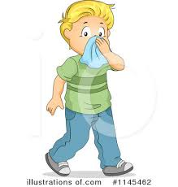

**يَرحَمُكَ الله**

|  |  |  |  |  |
| --- | --- | --- | --- | --- |
| **Rubric:** | **Ex.** | **Go.** | **Sat.** | **NI** |
| **Content Accuracy** | **1** | **2** | **3** | **4** |
| **Creativity** | **1** | **2** | **3** | **4** |
| **Completeness** | **1** | **2** | **3** | **4** |
| **Neatness** | **1** | **2** | **3** | **4** |
| **1-Excellent 2- Good 3- Satisfactory**  **4- Needs improvement** | | | | |