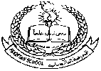 **Pakistan School, Kingdom of Bahrain**

**E- Support and Learning Material / Session 2020-2021**

**Subject: Islamiyat Grade: 1**

**Book: Islamiyat for primary classes FIRST TERM**

**Unit:4:Angels Pg. N0:16**

[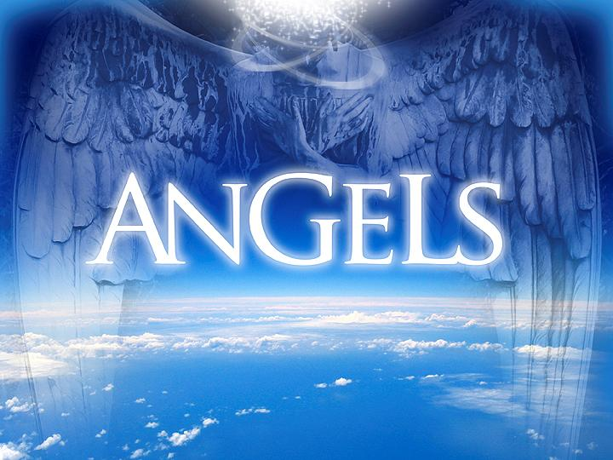](https://www.google.com.bh/url?sa=i&url=https://dwellingintheword.wordpress.com/2013/11/25/1191-hebrews-1/&psig=AOvVaw03S7mU0R7elVxeHI8YmgMP&ust=1585026961125000&source=images&cd=vfe&ved=0CAIQjRxqFwoTCNjjt-Drr-gCFQAAAAAdAAAAABAD)

**Difficult words:**

* Created Mud
* Sleep Drink
* Command Sleep
* Obey Work
* Commonly Believe

**Write the answer of the given questions:**

**Q1: What are human beings made of?**

Ans: Human beings are made of mud.

**Q2: what are angels made of?**

Ans:Angels are made of noor.

**Q3: Can we see angels?**

Ans: No, we cannot see angels.

**Q4: Do Angels pray to Allah?**

Ans: Yes , angels pray to Allah.

**Q5: Can angels see whatever we are doing?**

Ans: Yes , angels can see whatever we are doing.

**Q6: Name any two important angels.**

Ans: 1: Hazrat Jibraeel (AS)

2: Hazrat Izraeel (AS)

**Q7: How many angels Allah has given to each one of us?**

Ans: Allah has given two angels to each of us.

**Q8: Do angels eat or drink?**

Ans: No, angels do not eat or drink.

Use these words to fill in the blanks.

**angels, two, sleep, pray, noor**

1. Allah has given each one of us **two** angels.
2. Some **angels** protect us.
3. Angels don’t eat, drink or **sleep.**
4. Angels **pray** to Allah
5. Angels are made from **noor.**

**State whether the statements are True OR False.**

1. Angels cannot see us. ( F)
2. Angels are made from Noor. (T)
3. Angels obey Allah’s command. (T)
4. Angels can sleep.(F)
5. Angels protect us. (T)

**Subject: Islamiat WORKSHEET Grade: 1**

**Topic: Angels**

**Read the notes and lesson carefully and solve this worksheet.**

**Q1: Choose the Right answers:**

1. Angels made of__________. (Noor , Mud)

2. Angels do not ______ and sleep. (smile , eat)

3. Some angels __________ us. (protect, dangerous)

4. Angels __________ to Allah. (pray, disobey)

5. All Muslims believe in _________. (angels, human)

**Q2: State whether the statements are True OR False.**

1. Angels always obeys Allah’s commands. ( _____ )

2. Allah has created us. (______)

3. Allah has given each of us four angels. (______)

4. All angels work for Allah. (______)

5. We can see angels. (______)

**Q3: Match the following::**

|  |  |  |  |
| --- | --- | --- | --- |
| **1** | Angels can | mud |  |
| **2** | Human beings are made of | see us |  |
| **3** | Writing Angels are called | all the angels |  |
| **4** | Allah has given work to | Kiraman Katibeen |  |
| **5** | Allah has created | angels |  |

|  |  |  |  |  |
| --- | --- | --- | --- | --- |
| **Rubric:** | **Ex.** | **Go.** | **Sat.** | **NI** |
| **Content Accuracy** | **1** | **2** | **3** | **4** |
| **Creativity** | **1** | **2** | **3** | **4** |
| **Completeness** | **1** | **2** | **3** | **4** |
| **Neatness** | **1** | **2** | **3** | **4** |
| **1-Excellent 2- Good 3- Satisfactory**  **4- Needs improvement** | | | | |