**Pakistan School, Kingdom of Bahrain**

**E- Support and Learning Material / Session 2020-2021**

**Subject: Islamiat Grade : 3**

**Book: Islamiat for Primary Classes (FIRST TERM)**

**Pg. No: 24 (Reading of the lesson)** Unit 5: -

**Namaz**

**Difficult words.**

Answer these questions

**1- What is the second pillar of Islam?**

Ans- Namaz / salah is the second pillar of Islam.

**2- Write the names of steps of Namaz.**

Ans- Takbir-e-Tahrima

Qiyam

Ruku

Qiyama

Sajda

Quaidah

Salam

**3- What is Farz rakat?**

Ans: These are compulsory rakats, for each namaz.

**4- What is Sunnat rakat?**

Ans: These are offered to follow the Holy Prophet’s (S.A.W) practice.

**5- What is Nafl rakat?**

Ans- These are supplementary rakats for Allah’s blessings.

Write T for true and F for false statements

1- We should offer namaz / salat on time. **True**

2- The adan is called after namaz / salah . **False**

3- Namaz / salah is the second pillar of Islam. **True**

4- Namaz is not compulsory for all Muslims. **False**

5- We should do wazu before performing sallat. **True**

Choose the right answers

**1- Namaz is the key of**

a) reward b) blessings **c) success**

**2- The main difference between Muslims and Non-Muslims is**

a) clothes b) language **c) Namaz**

**3- Always do your best to offer prayer at**

**a) its right time** b) night time c) daytime

|  |  |  |  |
| --- | --- | --- | --- |
|  | **Names of Namaz**  Match column A with column B and write in column C | **Rakats** |  |
| 1 | Fajr | 12 | **2** |
| 2 | Zuhar | 8 | **3** |
| 3 | Asr | 7 | **4** |
| 4 | Maghrib | 4 | **1** |
| 5 | Isha | 17 | **5** |

**Subject: Islamiat WORKSHEET Grade : 3**

**Q1. Colour the picture and fill these blanks.**

**(Qibla Namaz Makkah)**

Before I begin my **__________** (salah) I lay my mat in the direction of **______________** which is Kabah in **_________________.**

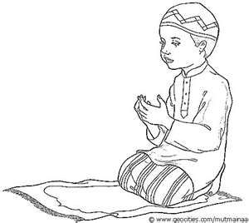

Homework:

**Q2. At what age Namaz is compulsory for a Muslim child?**

Ans: ____________________________________________________________.

**Q3. Name the five daily prayers in each petal:**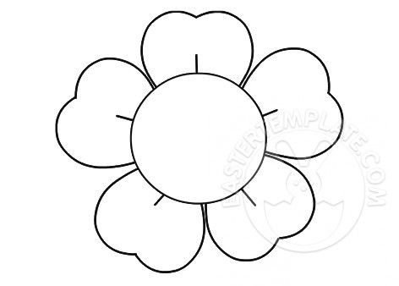

**Q4. Label the steps of Namaz:**

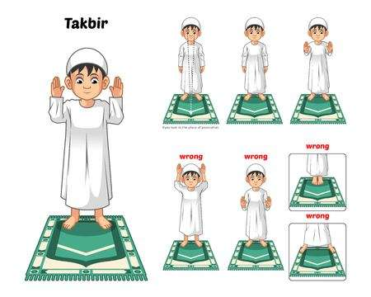 _____________________________________

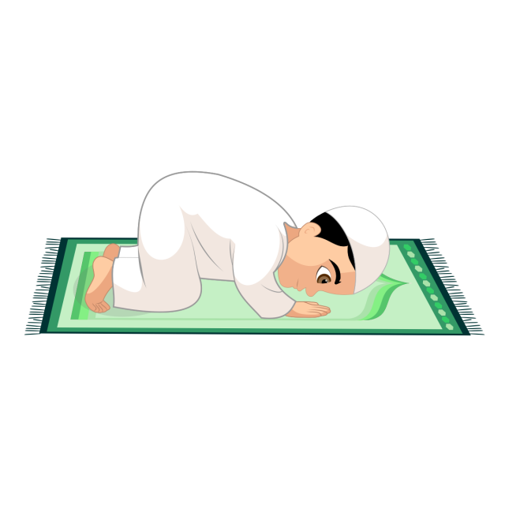____________________________________

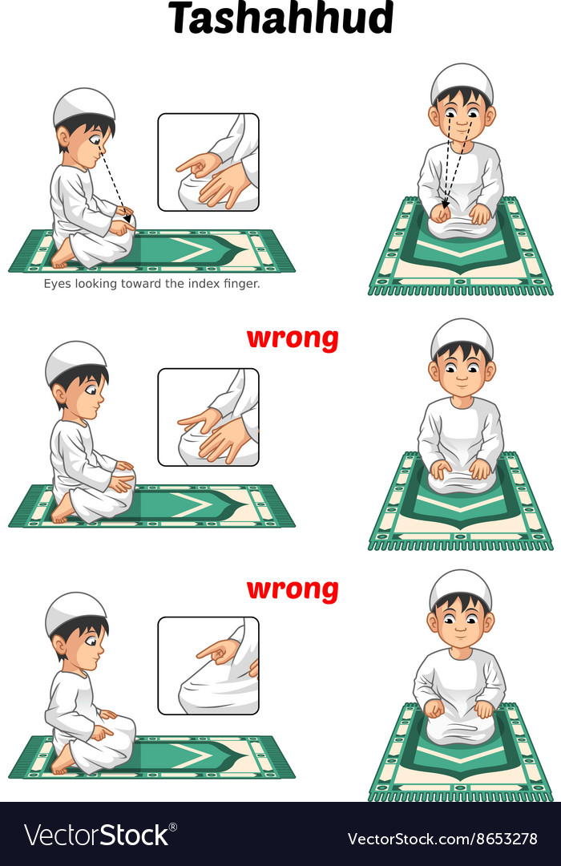______________________________

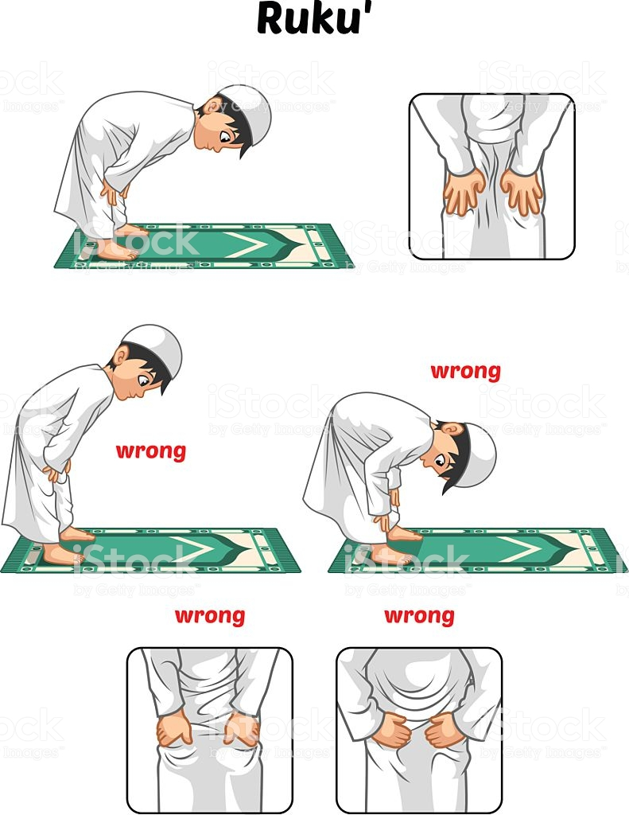_____________________________

|  |  |  |  |  |
| --- | --- | --- | --- | --- |
| **Rubric:** | **Ex.** | **Go.** | **Sat.** | **NI** |
| **Content Accuracy** | **1** | **2** | **3** | **4** |
| **Creativity** | **1** | **2** | **3** | **4** |
| **Completeness** | **1** | **2** | **3** | **4** |
| **Neatness** | **1** | **2** | **3** | **4** |
| **1-Excellent 2- Good 3- Satisfactory**  **4- Needs improvement** | | | | |