**Pakistan School, Kingdom of Bahrain**

**E- Support and Learning Material / Session 2020-2021**

**Subject: Islamiyat Grade: 4**

**Book: Islamiyat for Primary Classes Second Edition FIRST TERM**

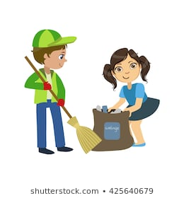 **Unit 11: Helping Others**



|  |  |  |
| --- | --- | --- |
|  | **Words** | **Meanings** |
| 1 | Fortunate | Lucky |
| 2 | Companion | Friend |
| 3 | Fulfill | complete |
| 4 | Grief | Pain |
| 5 | Blind | unable to see |
| 6 | Serve | to help |
| 7 | Charitable | Kind |
| 8 | Burden | Load |

**Short Q/A**

**Q.1 What does Islam teach us about brotherhood?**

Ans. Islam teaches us to be helpful to others and share our blessings with those who are less fortunate than us.

**Q.2 What did our Holy Prophet (SAW) say about helping others?**

Ans. Our Holy Prophet (SAW) said “Allah will help them who help others”.

**Q.3 How did Ansar help Muhajirs?**

Ans. When the Muhajirs arrived empty handed in Madina, the Ansar happily offered to share their belongings with them.

**Q.4 What did Hazrat Usman (RA) do to serve others?**

Ans. He used his wealth to buy and set free many slaves. He bought a fresh water well for everyone and also the land for Masjid-e-Nabvi.

**Q.5 What is Sadqa-e-Jaria?**

Ans. We can serve others by setting up schools, hospitals and mosques. It is called Sadqa-e-Jaria.

**Detailed Q/A**

**Q.1 How can we help others? Give some examples.**

Ans. There are many ways to help others.

1. To fulfill the need of a needy person.
2. To look after the sick.
3. To be kind to the poor.
4. To feel sorry for those who are in pain.
5. To help someone to cross the road.
6. To carry someone’s burden.

* **Exercise: FIB Book Pg. 46**
* **Complete these sentences using suitable words given.**

|  |  |  |  |  |  |
| --- | --- | --- | --- | --- | --- |
| **charitable** | **road** | **Sadqa-e-jaria** | **Abdul Sattar Edhi** | **wealth** | **sadqa** |

1. Ansar shared all their wealth with the Muhajirs.
2. Feeding a hungry person is the biggest sadqa.
3. Helping someone to cross the road is also an act of kindness.
4. Our dear Prophet(SAW) taught us to be charitable and helpful to the needy.
5. Setting up schools, hospitals and mosques is called Sadqa-e-jaria.
6. One person of our times who served others in a very big way was Abdul Sattar Edhi.

**Pakistan School, Kingdom of Bahrain**

**E- Support and Learning Material / Session 2020-2021**

**Subject: Islamiyat Grade: 4**

**Book: Islamiyat for Primary Classes Second Edition FIRST TERM**

**Unit 11: Helping Others Worksheet # 1**

**Name: __________________________ Date: _______________**

**Note: Write answers of any 2 of the following questions.**

**Q.1 Complete these sentences using suitable words given.**

|  |  |  |  |
| --- | --- | --- | --- |
| **kindness** | **Sadqa_e_jaria** | **Ansar** | **Islam** |

1. ____________________ shared all their wealth with the Muhajirs.
2. Helping someone to cross the road is also an act of _________________________.
3. Setting up schools, hospitals and mosques is called ___________________________.
4. __________________ is a religion of brotherhood.

**Q.2 Write one line for each of the following pictures in the boxes below.**

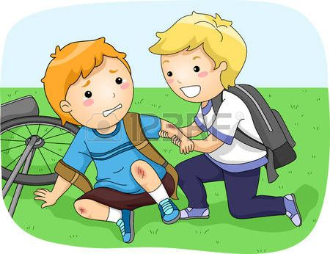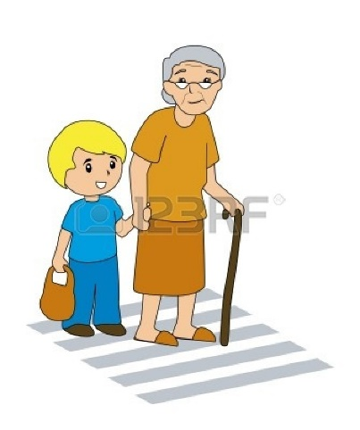

**Q.3 Write few lines about the importance of helping others in your own words.**

**Ans.**_____________________________________________________________________________________________________________________________________________________________________________________________________________________________________________________________________________________________________________________________

|  |  |  |  |  |
| --- | --- | --- | --- | --- |
| **Rubric:** | **Ex.** | **Go.** | **Sat.** | **NI** |
| **Content Accuracy** | **1** | **2** | **3** | **4** |
| **Creativity** | **1** | **2** | **3** | **4** |
| **Completeness** | **1** | **2** | **3** | **4** |
| **Neatness** | **1** | **2** | **3** | **4** |
| **1-Excellent 2- Good 3- Satisfactory**  **4- Needs improvement** | | | | |