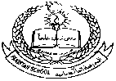**Pakistan School , Kingdom of Bahrain**

**E- Support and Learning Material / Session 2020-2021**

**Subject: Islamiyat Grade : H.K.G Sec:____**

**Name : ______________________ Isa Town / Manama**

***Topic no:5 Surah Al Ikhlaas***

***Listen and learn this surah:***

[***https://youtu.be/uv3VXLVK6FQ***](https://youtu.be/uv3VXLVK6FQ)

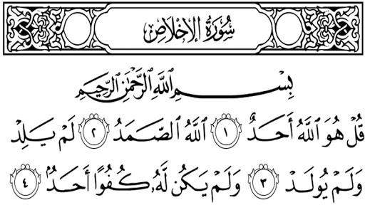

***Learn First Kalima (oral)***

