**Pakistan School , Kingdom of Bahrain**

**E- Support and Learning Material / Session 2020-2020**

**Subject: Social studies Grade : 1**

**Book: New Oxford Social studies for Pakistan-1 FIRST TERM**

**Unit 4: Lessons and Games Pg. No: 30-31**

**Lesson 7: School**



**Answer the following questions.**

**Q1: Why do you come to school ?**

Ans: I come to school to learn many things and have.

**Q2: What is your teacher’s name ?**

Ans: My teacher’s name is ________________.

**Q3: What is the name of your school ?**

Ans: The name of my school is Pakistan School.

**Fill in the blanks with suitable words:**

|  |  |  |
| --- | --- | --- |
| go | beautiful | write |

1. We learn to read and write at school.
2. We go to school.
3. Our school is a beautiful place.

**Fill in the missing letters:**

1. S c h o o l
2. t h i n g s
3. n u m b e r s
4. w o r l d
5. f a n

**Subject: Social Studies WORKSHEET GRADE:1**

**Q1. Colour and write the name of your school.**

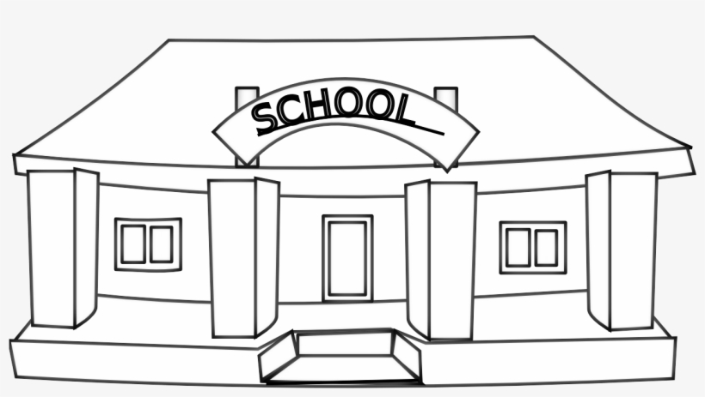

____________________________________________________________

**Q2: Name four things that you enjoy doing in school:**

**1-__________________________________________________.**

**2- __________________________________________________.**

**3- ___________________________________________________.**

**4- _____________________________________________________.**

**Q3. Put a circle round the things you learn at school.**

|  |  |  |  |
| --- | --- | --- | --- |
| **sums** | **writing** | **reading** | **fighting** |
| **dancing** | **drawing** | **shouting** | **games** |
| **flying** | **handicrafts** | **bad manners** | **singing** |

**Name the following pictures:**

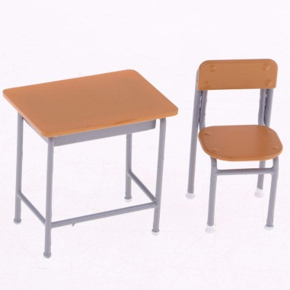 ___________________

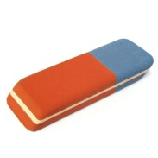 ____________________

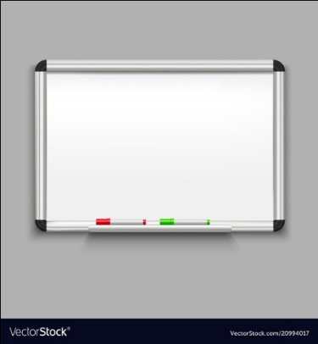 ____________________

 ____________________

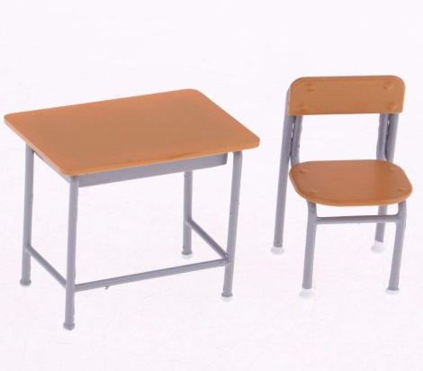 ______________________

|  |  |  |  |  |
| --- | --- | --- | --- | --- |
| **Rubric:** | **Ex.** | **Go.** | **Sat.** | **NI** |
| **Content Accuracy** | **1** | **2** | **3** | **4** |
| **Creativity** | **1** | **2** | **3** | **4** |
| **Completeness** | **1** | **2** | **3** | **4** |
| **Neatness** | **1** | **2** | **3** | **4** |
| **1-Excellent 2- Good 3- Satisfactory**  **4- Needs improvement** | | | | |