**Pakistan School, Kingdom of Bahrain**

**E- Support and Learning Material / Session 2020-2021**

**Subject: Social Studies Grade: 2**

**Book: New Oxford Social Studies FIRST TERM**

**Unit 2: Lsn: 5: Rules of staying healthy and safe Pg. No: 23 (Notes)**

**harmful __ every day__ zebra crossing __rubbish__ toilet __ electric**

1. We should have a bath **every day.**

2. Wash your hand after you have been to the **toilet.**

3. An **electric** shock can kill.

4. Dirt and pollution and **harmful** for our health.

5. You must not throw **rubbish** on the roads.

6. Cross the road at **zebra crossing.**

**State Whether these statements are True or False.**

1. We should not brush our teeth every day. **(F)**

2. Cut your nails and keep them clean**. (T)**

3. Flies like clean places. **(F)**

4. Mosquitoes like lay their eggs in dirty water. **(T)**

5. Accidents not happen if we are careful. **(T)**

6. An electric shock can save us. **(F)**

1. We should cut our nails and keep them **clean.** (clean, dirty)

2. We should brush our teeth **every day**. (every month, every day)

3. Eating too much **sweets** cause tooth decay. (healthy food, sweets)

4. Flies like **dirty** places. (clean, dirty)

5. A mosquito bite can make you **ill**. (ill, healthy)

6. Medicine that is not for you may harmyou. (save, harm)

7. Be careful while crossing the **road**. (road, floor)

|  |  |  |  |
| --- | --- | --- | --- |
| **1** | Shower | Hair | **3** |
| **2** | Electric shock | Itching | **4** |
| **3** | Comb | Dirty places | **5** |
| **4** | Lice | Everyday | **1** |
| **5** | Mosquitoes | Kill | **2** |

**Subject: Social Studies WORKSHEET Grade:2**

**Name the following pictures:**

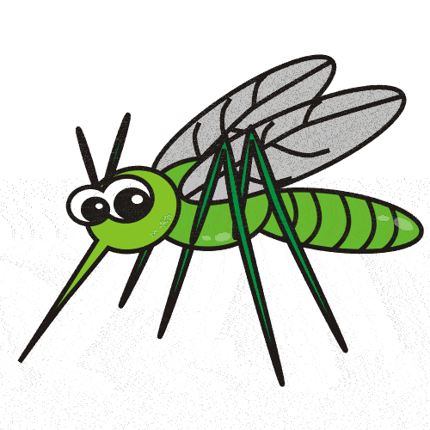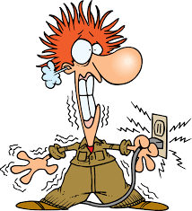

**____________________ _____________________**

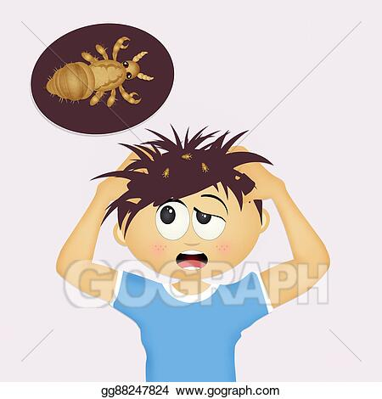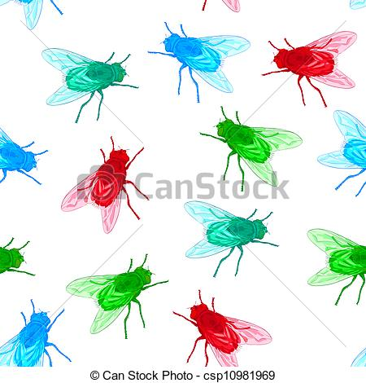

**_____________________ _____________________**

|  |  |  |  |  |
| --- | --- | --- | --- | --- |
| **Rubric:** | **Ex.** | **Go.** | **Sat.** | **NI** |
| **Content Accuracy** | **1** | **2** | **3** | **4** |
| **Creativity** | **1** | **2** | **3** | **4** |
| **Completeness** | **1** | **2** | **3** | **4** |
| **Neatness** | **1** | **2** | **3** | **4** |
| **1-Excellent 2- Good 3- Satisfactory**  **4- Needs improvement** | | | | |