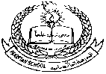 **Pakistan School , Kingdom of Bahrain**

**E- Support and Learning Material / Session 2020-2021**

**Subject: Social Studies Grade : 3**

**HISTORY AND GEOGRAPHY OF BAHRAIN**

Q1: What does Bahrain mean?

Ans: Bahrain means “two seas”.

Q2: Where is Bahrain located?

Ans: Bahrain is located on the north eastern coast of Saudi Arabia.

Q3: How many islands are there in Bahrain?

Ans: The Kingdom of Bahrain consists of 33 natural islands.

Q4: What are the natural resources of Bahrain?

Ans: Petroleum and natural gas are the only significant of natural resources of Bahrain.

Q5: What is the old name of Bahrain?

Ans: The old name of Bahrain is Tylos.

Q6: Which language is spoken in Bahrain?

Ans: Arabic Language is spoken in Bahrain.

**State whether the statements are True or False:**

1. Bahrain is located between England and Germany. F

2. Bahrain consists of 33 natural islands. T

3. Harbour is the old name of Bahrain. F

4. Arabic language is spoken in Bahrain. T

5. Bahrain means two seas. T

**Fill in the blanks:**

1. Bahrain means two seas.

2. Bahrain is located on the north eastern coast of Saudi Arabia.

3. Arabic language is spoken in Bahrain.

4. Bahrain consists of 33 natural islands.

5 .The old name of Bahrain is Tylos.

**Subject: Social Studies WORKSHEET GRADE: 3**

**Q1. Answer these questions:**

**1. What is the old name of Bahrain?**

**A:____________________________________________________________________________**

**2. Where is Bahrain located?**

**A:____________________________________________________________________________**

**Q2. Fill in the blanks:**

**1. Bahrain consists of __________ natural islands**

**2. ______________ language is spoken in Bahrain.**

**Q3. State whether the statement is True or False:**

**1. Bahrain means two seas. __________**

**Colour the Flag of Bahrain**

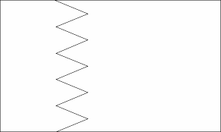

**Draw and colour the Map of Bahrain.**

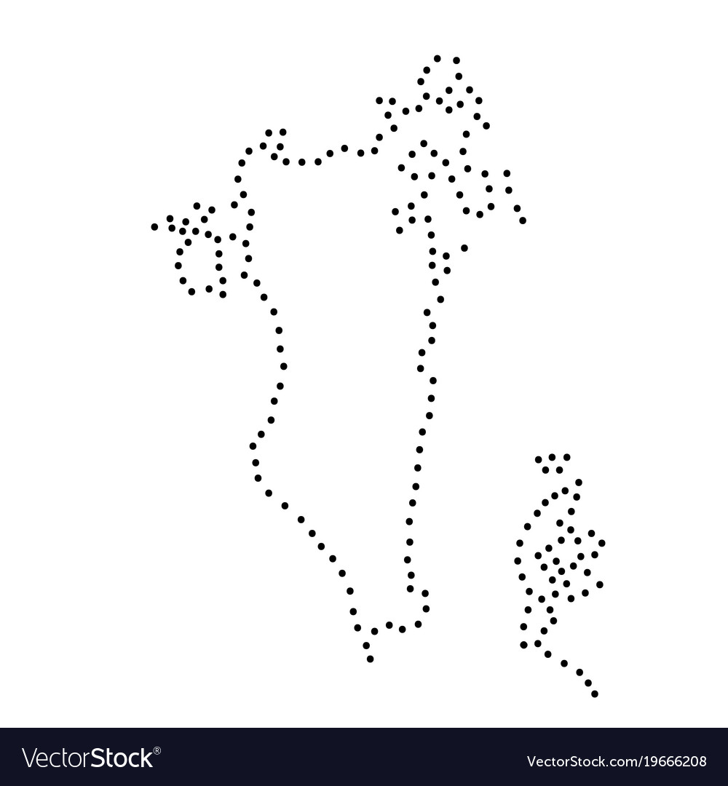

|  |  |  |  |  |
| --- | --- | --- | --- | --- |
| **Rubric:** | **Ex.** | **Go.** | **Sat.** | **NI** |
| **Content Accuracy** | **1** | **2** | **3** | **4** |
| **Creativity** | **1** | **2** | **3** | **4** |
| **Completeness** | **1** | **2** | **3** | **4** |
| **Neatness** | **1** | **2** | **3** | **4** |
| **1-Excellent 2- Good 3- Satisfactory**  **4- Needs improvement** | | | | |