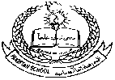**Pakistan School , Kingdom of Bahrain**

**E- Support and Learning Material / Session 2020-2021**

**Subject: Science Assignment:5 (notes) Grade : 7th**

**Book: Oxford Secondary Science Book 2 FIRST TERM**

**Chapter 7: Water, water everywhere Pg. No: 79,80**

**Topic 4 : Distillation Page no: (79,80)**

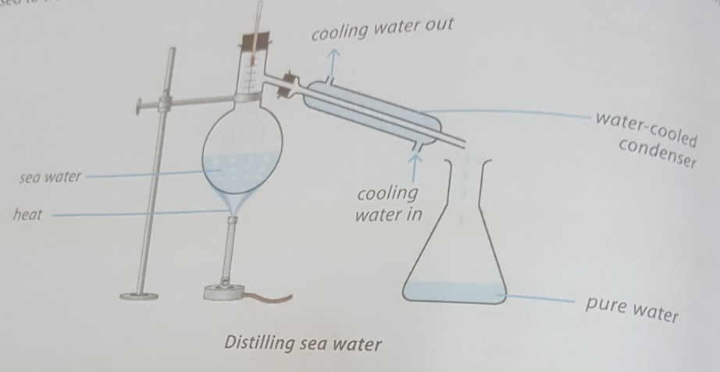

**Q.1 What is desalination or distillation?**

**Ans.** Desalination is a process to remove salt from sea water. Today many desalination plants are used to turn sea water into drinking water in gulf and other countries.

**Q.2 Which countries use distilled water?**

**Ans.** Saudi Arabia, UAE, Qatar, Bahrain, Libya

**Q.3 What are the problems with distillation or desalination plants?**

Ans. 1.It is not cheap because it requires large quantities of fuel to heat the sweat water

1. Pesticides cannot be removed by distillation
2. Distilled water is not suitable for drinking. It lacks some of the minerals

**Topic 5 : Water cycle page no :79,80**

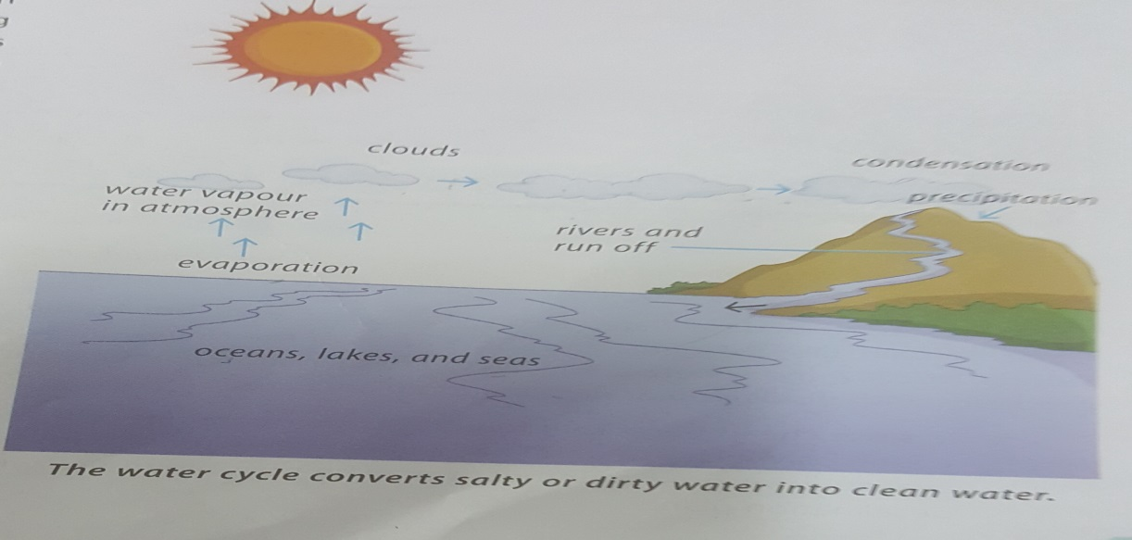

**Q.1 What is water cycle?**

**Ans.** The continuous process by which water is circulated through the earth and atmosphere through different stages is called water cycle.

**Q.2 What are the four main parts of water cycle?**

Ans. 1.evaportaion, condensation, precipitation and transpiration

**Q.3 How you will explain water cycle?**

Ans. 1.First water on the surface of earth evaporates. It is called evaporation

2. water collects as water vapors in the sky

3. water vapor contact with cooler air and condenses. It is called condensation.

4.water falls from the sky as rain , snow .

5.water flow back into ocean, seas and lakes