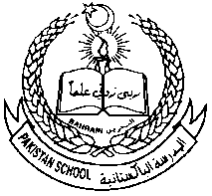 **Pakistan School , Kingdom of Bahrain**

**Portion For Annual Examination, March 2021**

**Grade: 7th Subject: Social Studies.**

|  |  |
| --- | --- |
| **Sr. #** | **Chapters** |
| **1** | **Chapter#13. The Environment of South Asia** |
| **2** | **Chapter #15 Citizenship, rights and values** |
| **3** | **Chapter #22 The Mughals** |
| **4** | **History and Geography of Bahrain.** |

**Note : Everything in the notes and Textbook is included.**