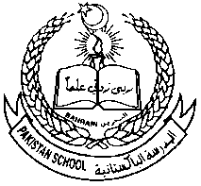 **Pakistan School , Kingdom of Bahrain**

**Portion For Annual Examination, March 2021**

**Grade: 8th Subject: Social Studies.**

|  |  |
| --- | --- |
| **Sr. #** | **Lesson /Unit/Topics** |
| **1** | **Ch. 9 Major Occupations in the world.** |
| **2** | **Ch. 10. World environment and its problems.** |
| **3** | **Ch. 18. Explorer, Scientists and inventors.** |
| **4** | **History and Geography of Bahrain.** |

**Note : Everything in the notes and Textbook is included.**