**PAKISTAN SCHOOL, ISA TOWN BAHRAIN**

**PRE BOARD EXAMINATION 2021**

**Class: 12th Marks: 40**

**Paper: Business Statistics Time: 2:15hrs**

**Section B**

**Q: 2 Attempt any eight parts. All parts carry equal marks. (8x3=24)**

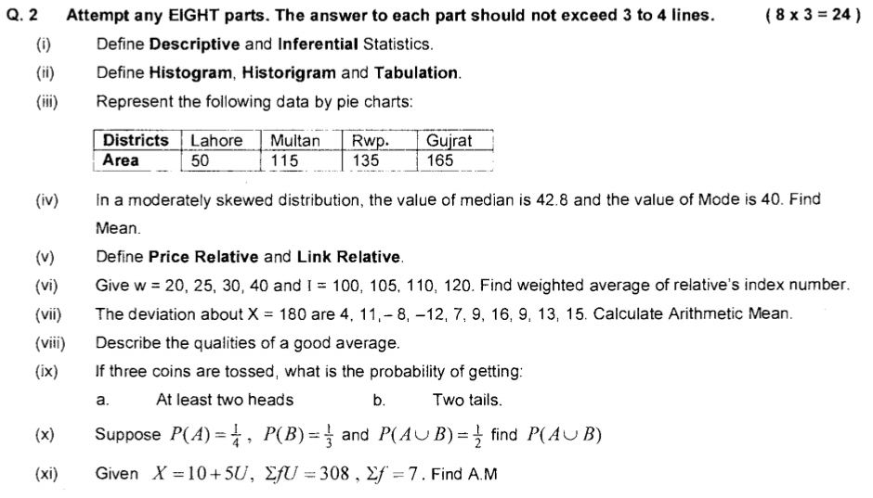

1. Define Statistic and parameter
2. Average weight of 10 students is 60 kg and average weight of 15 students is 64 kg. Find average weight of all 25 students.
3. Find index number from the following data by taking 1972 as base year.

|  |  |  |  |  |  |
| --- | --- | --- | --- | --- | --- |
| **Year** | 1970 | 1971 | 1972 | 1973 | 1974 |
| **Prices** | 9 | 6 | 8 | 11 | 10 |

**Section C**

**Note: Attempt any two questions from Section C. (8x2=16)**

1. Calculate arithmetic mean of the following by:
   1. Direct method
   2. Indirect method
   3. Step-deviation method

|  |  |  |  |  |  |  |  |
| --- | --- | --- | --- | --- | --- | --- | --- |
| **Class limits** | 30-39 | 40 – 49 | 50 – 59 | 60 – 69 | 70 – 79 | 80 – 89 | 90-99 |
| **f** | 1 | 3 | 11 | 21 | 43 | 32 | 9 |

1. From the following data, find index number for 2000 on the basis of 1990 using:
   1. Base year weighted method
   2. Current year weighted method
   3. Fisher’s ideal index

|  |  |  |  |  |
| --- | --- | --- | --- | --- |
| **Items** | **1990** | | **2000** | |
|  | **Price** | **Quantity** | **Price** | **Quantity** |
| A | 2 | 10 | 4 | 8 |
| B | 4 | 5 | 5 | 6 |
| C | 5 | 8 | 6 | 10 |
| D | 3 | 20 | 3 | 25 |

1. Compare budgets of two families by sub-divided rectangular bar chart.

|  |  |  |
| --- | --- | --- |
| **Items** | **Budgets of** | |
| **Family A** | **Family B** |
| Food | 240 | 350 |
| Clothing | 120 | 130 |
| House Rent | 140 | 200 |
| Fuel | 80 | 100 |
| Education | 100 | 120 |
| Misc. | 120 | 100 |

**PAKISTAN SCHOOL, ISA TOWN BAHRAIN**

**PRE BOARD EXAMINATION 2021**

**Name: ___________________ Class: _____**

**Paper: Business Statistics 12th Time: 15min**

**Section A.**

**Q: 1 Choose the correct answer. (1x10=10)**

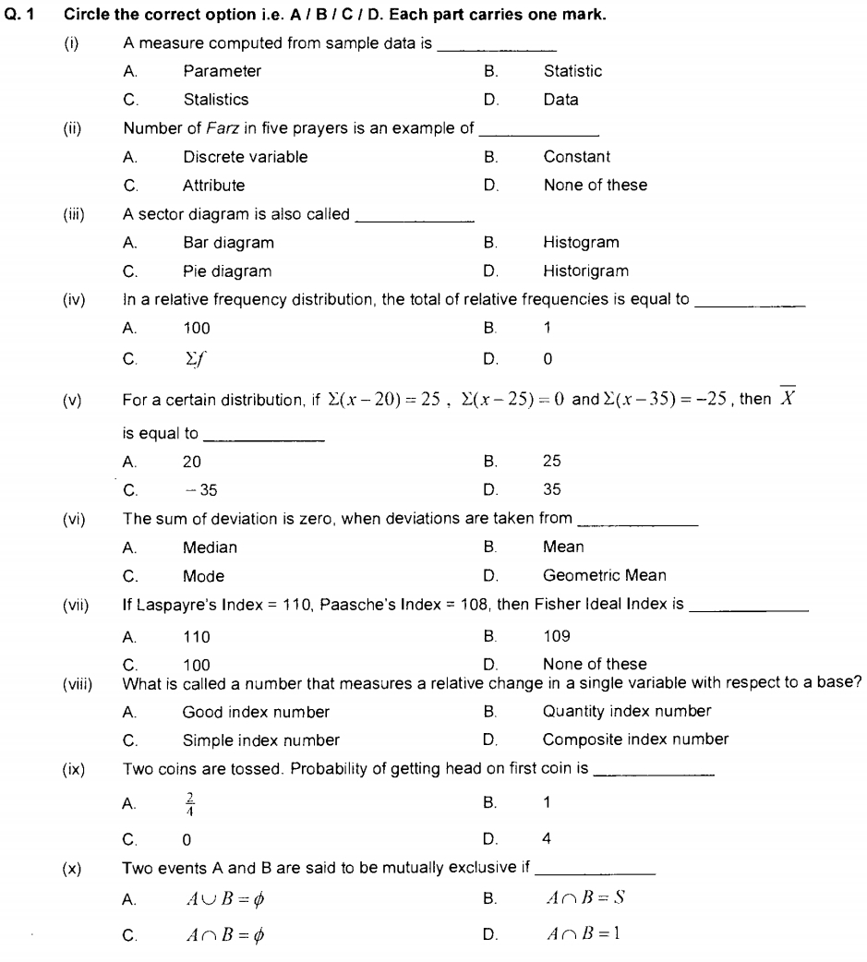

(ix) A small representative part of population is called

A. Primary data B. Secondary data

C. Sample D. Parameter

(x) If all the values are not of equal importance, then it is called ________ index number

A. Simple B. Composite

C. Un weighted D. Weighted