** Pakistan School, Kingdom of Bahrain**

**HSSC Pre Board Examination, June 2021**

**Class: 11th Sec_____ Total Marks: 20**

**Subject: Economics-I Time Allowed: 25Mins**

|  |  |  |  |
| --- | --- | --- | --- |
| **7** | **3** | **5** | **0** |

**Student’s Name: ___________________________________ Version No:**

**NOTE: : Section A is compulsory. All parts of this section to be answered on the separately provided OMR Sheet which should be completed in the first 20 minutes and handed over to the Centre Superintendent. Deleting/overwriting is not allowed. Do not use lead pencil.**

**SECTION – A ( Marks-20 )**

**Q1. Choose the correct answer A/B/C/D by filling the relevant bubble for each question on the OMR Answer Sheet according to the instructions given there. Each part carries 1 mark.**

1. Who introduced the concept of Indifference Curves to explain consumer's behaviour?

A. Adam Smith B. J.R. Hicks C. Alfred Marshall D. Lionel Robbins

1. Decrease in demand due to rise in price is called:

A. Contraction B. Extension C. Fall D. Rise

1. When both demand and supply fall proportionately, price of the commodity will be:

A. Rising B. Falling C. Same D. None of these

1. 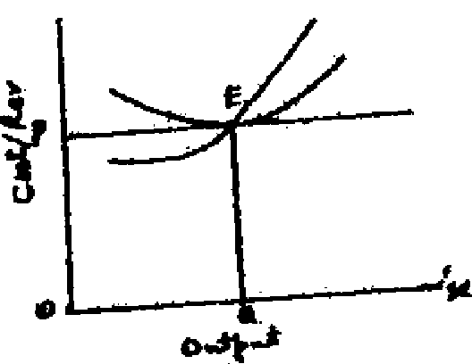According to the given diagram, what type of profit / loss is faced by the firm?

A. Normal profit B. Super — normal profit

C. Sub-normal profit / loss D. Shut down position

1. Which one of the following is a continuous variable?

A. Population B. Time

C. No. Of students in a class D. Exports of Pakistan

1. If a consumer moves upward along an Indifference curve, his total utility:

A. Equal to zero B. Does not change

C. Increases D. Decreases

1. When Demand rises more than rise in Supply, then Price of the Product will:

A. Rise B. Fall C. Remain constant D. None of these

1. In Monopoly and Perfect Competition, Cost curves are:

A. Similar B. Different

C. Opposite D. Fall in Perfect competition, rise in Monopoly

1. All inputs can be varied in:

A. Short period B. Long period

C. Both short and long periods D. None of these

1. In MR (Marginal Revenue) is always equal to price.

A. Perfect competition B. Monopoly

C. Both A and B D. None of these

1. When average cost (AC) curve rises, marginal cost (MC) curve remains:

A. Above AC B. Below AC C. Equal to AC D. None of these

1. Who was the exponent of Welfare economics?

A. Alfred Marshall B. Adam Smith C. Robbins D. Keynes

1. The utility of an additional unit of a product is:

A. Marginal utility B. Total utility C. Negative utility D. Average utility

1. If total product is divided by the total number of labour used to produce the product, we get

A. Average product B. Marginal product

C. Total product D. Total Cost

1. Which of the following is considered as price?

A. Total revenue B. Marginal revenue C. Average revenue D. Average cost

1. Marginal Cost curve intersects Average Cost curve where:

A. Marginal cost is minimum B. Average cost is minimum

C. Marginal cost is maximum D. Average cost is maximum

1. Under the conditions of Monopoly, the demand curve of the firm is:

A. Positively sloped B. Negatively sloped

C. Perfectly elastic D. Perfectly inelastic

1. If fixed cost is deducted from total cost, we get:

A. Marginal cost B. Average cost C. ' Variable cost D. Profit

1. Short run is a time period in which:
2. The size of the trim/plant can be altered
3. The amount of output is fixed '
4. The units of all factors of production can be changed

D, The units of some factors of production remain fixed and the units of other factors can be changed

1. Given the equation y = —10 ± 2x . the slope of the equation is:

A. —10 B. 2 C. —8 D. —12

** Pakistan School, Kingdom of Bahrain**

**HSSC Pre Board Examination, June 2021**

**Class: 11TH Sec_____ Total Marks: 80**

**Subject: Economics – I Time Allowed: 2:35 HRS**

**Student’s Name: _________________________________________**

**NOTE: Section B & C comprises 1-2 pages. Answer all the questions from section B-Con a separate sheet. Write your answers neatly and legibly.**

**Section B (Marks – 50)**

**Q2. Answer any fifteen parts. All parts carry equal marks. (15x3=45)**

I. What is the deductive method of derivation of economic laws?

II. Write the conditions of consumer's equilibrium

III. Differentiate between 'Expansion of demand' and 'Rise of demand'.

IV. Solve the following equations to find equilibrium price and quantity when Qd=Qs

Qd=12-2P & Qs=3+P

V. Describe three relations of average cost and marginal cost.

VI. Define Variable Cost and Fixed Cost.

VII. State law of Diminishing Marginal Utility.

VIII. Draw a demand curve with the help of functional equation Qd=30 — 5P

IX. What will be the new equilibrium price and quantity if demand increases more than supply? Show graphically.

X. Define income Elasticity of demand with formula.

XI. Differentiate between Marginal revenue and Average revenue.

XII. What do you mean by normal profit?

XIII. Differentiate between continuous and discreet variable?

XIV. How equilibrium price and quantity is affected when demand rises and supply falls equally?

XV. What do you mean by market period supply?

XVI. Classify market on the basis of nature of competition.

XVII. Draw marginal revenue and average revenue curves under perfect competition.

XVIII. Define monopolistic competition.

XIX. What are the necessary conditions for a firm’s equilibrium?

XX. Define total, average and marginal cost.

**b. Attempt any one part.** **(1x5)**

i) What conditions do exist in a perfectly competitive market?

ii) By using the below given schedule, find the functional equation of supply

|  |  |  |
| --- | --- | --- |
| P | 1 | 2 |
| Q | 15 | 20 |

**Section- C (Marks 30)**

**Note: Attempt any three questions. All questions carry equal marks.**

**(3x10=30)**

Q3. Explain equilibrium of a firm in Short-run and long-run under perfect competition. Make diagrams.

Q4. Explain the "Law of Demand" with the help of a schedule and diagram.

Q5. Explain the Unity Method in the measurement of elasticity of demand.

Q6. What is monopoly? Explain the price and output determination under monopoly.