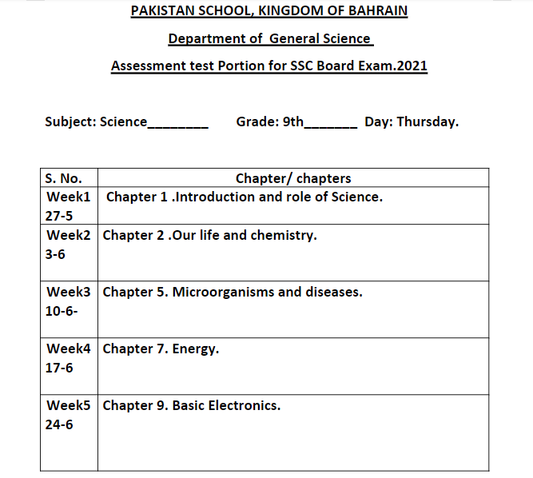

Note:
- Any MCQs and short Q/A will be included from reduced syllabus already provided and available on FBISE website.
- Assessment test will be of 20 marks

